**BULACAN POLYTECHNIC COLLEGE**

*Bulihan*, City of Malolos, Bulacan

Associate in Computer Technology

**Barangay Information System - Caingin**

**Submitted by:**

**Ralph Alba**

**Princess Nicodemus**

**Allen Isaias**

**John Louie C. Marcelino**

**CHAPTER I**

**INTRODUCTION**

Our system is designed to assist barangay officials in their work, providing support in today’s world where technology is becoming increasingly prevalent.

**Project Context**

The project aims to create a tool that helps barangay officials manage and organize important reports and resident information. As technology becomes central to modern life, this system can benefit barangay operations by providing a digital alternative to traditional manual methods. The project allows our team to apply and showcase the skills and knowledge they’ve gained from our professors, contributing a meaningful tool for community service. Through this system, our team demonstrates that local government units can use technology to improve efficiency, transparency, and accessibility, reflecting a vision of a more organized and technologically engaged barangay ready to meet the evolving needs of its residents.

**Purpose and Description**

***Status of the Current System***

What we observe in other barangays is that they still process reports or complaints from their residents manually. This manual approach often leads to delays, miscommunication, and difficulty in tracking and organizing records. By creating a digital system, we aim to address these challenges, helping barangay officials respond more effectively and keep a comprehensive record of all resident concerns.

***Replacing the Current System***

We created a system that covers the essential tasks of barangay officials, including handling reports or complaints from residents, managing the barangay census with important resident information, and updating the barangay’s total population in real-time when people move in or out. Additionally, the system includes a barangay calendar to keep track of upcoming community events. Our system has a retrieval feature to prevent the loss of information or complaints stored within it, and our goal is to keep information and reports organized to help barangay officials work more efficiently.

**Objectives of the Project**

The main objective of the study is to develop a system that can help them to their works.

1. **Automate Report Management** - Provide an automated method for residents to submit and retrieve reports, reducing the time and effort required in the process.
2. **Centralized Database** - access and Create a centralized database for all resident information and reports to streamline organization.
3. **Barangay Calendar** - Implement a feature to track upcoming barangay events, including details such as date, time, and location.
4. **Data Security** - Ensure the security of all data by implementing security measures and access controls.

**5. Population Statistics** - Provide real-time statistics on the total population of the barangay to assist in planning services and projects.

**Statement of the Problem**

Specific problems:

1. Manual entry of reports/complaints
2. No retrieval in the reports/complaints.

3.The reports/complaints are not organize.

**Scope and Limitations of the Study**

The scope of the study focuses on organizing the reports/complaints received from residents and assisting the officials/staff in organizing information that they can retrieve using our system.

Although the system’s features can greatly improve the works of the barangay officals or staffs our system are facing some limitations like if there are some power interuptions.

The advantages of our system include making your work easier, as it consolidates all essential information held by officials and staff, such as census data, reports/complaints, the barangay calendar, and the total population of the barangay. Additionally, the information or complaints gathered in our system include retrieval capabilities along with the date and time they were saved.

**Significance of the Study**

The result of the study and development of the proposed system will benefit the following stakeholders:

**Barangay Secretary** - The sectretary are the admin in the system.

**Personnel/Staff -** They can enter the information they've gathered into the system, as they are responsible for collecting data on each resident in their barangay.

**Residents**- The reports or complaints provided to the secretary are recorded in the system if the secretary verifies the proof.

**Other Researchers -** The study may guide the researchers in implementing limited and specific functions for a management system.

**CHAPTER II**

**REVIEW OF RELATED STUDIES AND TECHNICAL BACKGROUND**

This study represent the review of related literature are associated on Barangay Infomation System The purpose of this study is to let the readers cater the information about the topic.

**Foreign Studies**

**The Development of a Village Information System (SID) in Realizing a Developed and Independent Village Based on Information Technology and Communication (ICT) in Pemalang Regency (2021)**

Nunik Retno Herawati, Muhammad Adnan, Yuwanto Yuwanto

Since the emergence of Village Law No. 6 of 2014 concerning Villages, the village is seen as a government structure that plays an important role in realizing the prosperity and welfare of its people. Internet-based rural development paradigm is important to do in the middle of the development of information and communication technology. However, it is not easy to carry out the development of information and communication technology. Research have tried to describe how the Local government Pemalang district along the village government to develop and implement the development of System information village. The study also tried to describe the obstacles faced, strategic efforts that have been made and explain the perceived benefits of the village government since the development of information system for the village of governance early and public service for the village community. This study uses qualitative research methods to approach phenomenology locus of research in Pemalang district. The procedure is done through assessment theory and collecting dat a good primary as well as secondary data. Data primary derived from in-depth interviews with the head and staff Bapermasdes and the Head and staff of the Department of Communications and Informatics as well as some of the village chief in the district of pemalang, while secondary data obtained from the regulations, reports, or from the Internet.

**Analysis of The Use of Village Information System (SID) In Supporting The Acceleration of Village Development In Pegajahan District, Serdang Bedagai Regency (2023)**

Cakra Reksa Wijaya, Sirojuzilam Sirojuzilam, Badaruddin BadaruddinThe aim of this research is to: 1) analyze the implementation of the Village Information System in Pegajahan District, Pegajahan District, Serdang Bedagai Regency, and 2) analyze the influence of the Village Information System in supporting the acceleration of village development in Pegajahan District, Pegajahan District, Serdang Bedagai District. Research was carried out in Pegajahan District, Serdang Bedagai Regency regarding the Effect of Using Village Information Systems (SID) in Supporting the Acceleration of Village Development in Pegajahan District, Serdang Bedagai Regency. The analytical method used in this research is multiple regression analysis, with a total of 99 respondents. The research results showed that the implementation of the Village Information System in Pegajahan District, Serdang Bedagai Regency went very well because it was in a very positive area based on score interpretation. The Human Resources variable (X1) has an average total value of 3.94. The infrastructure variable (X2) has an average total value of 4.00. The institutional and budget variables (X3) have an average total value of 4.00. The IT service variable (X4) has an average total value of 4.06. The influence of the Village Information System which includes the variables Human Resources (X1), facilities/infrastructure (X2), institutions and budget (X3), and IT services (X4) has a positive and significant influence on the acceleration of village development in Pegajahan District, Serdang Bedagai Regency.

**Development of Village Applicant Capacity Training Model Based on Village Information System in Village Community Empowerment Department in Langkat District (2020)**

Robinson Hutagaol, Abdul Hasan Saragih, Sahat Siagian

This study aims to: (1) produce an Addcie model for training the capacity of village apparatus based on village information systems, which is suitable for use in training the capacity of village officials (2) to determine the effectiveness of the Addcie model for training the capacity of village officials based on the village information system. This type of research is research and development using the R & D model from Borg and Gall combined with the instructional design model from Dick and Carey. The research method consists of two stages, namely stage I developing a training learning model and conducting trials, and stage II conducting product effectiveness testing. In the development and testing stage the product must go through a series of validation and trial processes. The results showed that (1) the material expert's assessment was very good, (82.94%), (2) the learning design expert's assessment was very good (81.58%), (3) the expert assessment of the learning model was on very good criteria (94.42%), (4) the assessment of media experts is in very good criteria (85%), (5) the assessment of individual trials is in very good criteria (81.03%),(6) assessment of small group trials is also in very good criteria (90.09%), (7) the assessment of limited field trials which are in very good criteria (92.08%).

**Local Literature**

**Barangay Profiling System with Analytics (2021)**

Bernard Jacobe, Mark Lester Pascua, Billy Jay Tumbali, Maria Clarissa Aquino, Maria Visitacion Gumabay

This study aimed to develop a Barangay Profiling System with Analytics for Barangay Pallua Sur Tuguegarao City. It aimed to prowide systematic profiling system which can the authorized users casily manage resident's profile, generate statistical reports, and the provision of updating the records The researchers utilized qualitative approach using descriptive research design and systems development in collecting, analyzing the data and the design and development of the system. The researchers concludes that the developed system automates the profiling of all residents in the barangay. It stores data electronically thus, records are more organized, and also it provides an access of the information needed by the barangay. Reports needed with statical analysis can be easily generated.  
  
**Barangay Constituents Information and Services Management System (2021)**

Teresita T. VillonesAs the global environment ages, the emerging trend for Information Technology has risen above the development initiatives' surface. The Barangay currently used a manual process in issuing Barangay Certificates, Business Permit, Summon Letter, etc. This caused a lengthy procedure in accessing the records and files, which sometimes cause record redundancy. The study study's objective was to design and develop a Barangay Constituents Information and Services Management System to improve record retrieval in the Barangay, Research methodology used in this study was developmental and descriptive research. Likewise, an Herative systems development model was used in the design and development of BCISMS. It uses developmental research since this study involves creating a database system that could use for the Barangay. Descriptive analysis because IT Experts evaluated the BCISMS based on McCall's Software Quality Standards and Barangay Respondents on ISO/IEC 9126-1:2000 Quality. Interview approach was used in collecting information to know the manual process in the Barangay. The iterative Systems Development approach is used to come up with the proposed BCISMS. Respondents of the study were the Punong Barangay, Barangay Kagawad, and Barangay Secretary, Researcher conducted interviews on-site with the Punong Barangay, Barangay Kagawad, and Barangay Secretary. Evaluation instruments used were MeCall's Software Evaluation Criteria for Software Quality Model und ISO/IEC 9126-1-2000. Software Quality Model Characteristics. The Barangay Constituents information and Services Management System were Very High in the result. It shows that the system was capable of managing records of the barangay and reliable in handling data for further use.  
(Minimum of 3 studies)

**Development of an Information Based Dashboard Automation of Barangay Information Profiling System (BIPS) for Decision Support Towards E-Governance (2020)**

Angelique D. Lacasandile, Mideth B. Abisado, Rogel M. Labanan, Lalaine P. Abad  
The need to address societal issues of every community is a salient aspect that demands attention from the people in authority. These are important responsibilities of every barangay and its official in the Philippines. Profiling each household in the community using information and communication technology could achieve good governance through E-government as its core. Once profile data is aggregated, essential information could provide statistics in labor and employment, family income and expenditures, demography by (population) and (age), water and sanitation, type of housing and education. The focus is based on the profiling of Zone 42 and adding other profile data is aggregated, essential information could provide statistics in labor and employment, family income and expenditures, demography by (population) and (age), water and sanitation, type of housing and education. The focus is based on the profiling of Zone 42 and adding other facets as mentioned above was initiated, with the idea that educational institution around the barangay can help towards the areas included. This paper intends to aid barangay official in budget allocation and decision making in their respective governed area with the use of Barangay Information Profiling System (BIPS). Building an Information-Based Dashboard was initiated last 2016 and assessed by IT expert, was given readiness for beta launch to its target users. The functionality criteria were given a mean score of 4.47, which means that the respondents agreed that the system sequence of operation is easy to understand, and the result of their queries is correct and accurate. The system testing had a favorable result with a mean of 4.50 which means that the system passed the standard of completing, processing of a request, response time and the usage of computer resources for all of its function.

**Technical Background of the Project**

Our system is designed to help officials and staff gather information from residents. It focuses on making their work easier, particularly in handling census data, reports or complaints from residents, and the total population of the barangay.

**Technical Background of the System**

The barangay information system is a standalone system that users can access and operate without an internet connection. This system enables users to create, edit, and delete the information they have gathered. Additionally, it allows users to manage reports or complaints submitted by residents, including creating, updating, and removing entries as needed. the following technology tools are being used:

**(Programming Language C#)** – C# is an object-oriented programming language developed by Microsoft, designed to allow developers to build applications on the .NET platform. It originates from the C family of languages and shares many features with C, C++, Java, and JavaScript. This language enables the creation of systems capable of performing operations such as creating, reading, updating, and deleting information.

**CHAPTER III**

**METHODOLOGY OF THE STUDY**

During the qualitative studies, the barangay and its officials and employees were interviewed and observed in order to identify the flow of work and the necessary needs and features. To create this kind of stand-alone, offline application for census data, complaints from residents, and population management, the system was designed using C# programming. Its features included database consolidation, automatic generation of reports, real-time population statistics, as well as the barangay calendar on events. Basic implementation of the developed system was made and tested where the system was evaluated in a controlled environment. Information on the efficiency of the system was incorporated in successive cycles of system enhancements for functionality, dependability, and ease of use. This was helpful because it made certain the system fit all the requirements of the barangay officials.

**Design and Development**

***Research Design (Qualitative/Quantitative/Mixed Method)***

This study thus endeavored to address some of the issues arising from the management of residents’ information and reports through the use of descriptive and developmental research with the barcode scanning system. Exploratory or descriptive research was undertaken in a bid to identify the issues that currently characterize the manual system. An interview and observation were also conducted, and the problems identified included having to manually report, retrieve, and arrange records. Based on developmental research, the barangay information system was conceptualized and developed. This required developing the system concept, creation of a prototype, and subsequent redesign to match the requirements; therefore, the system solution procured was customized to correspond to the specified requirements in the area of efficiency and reliability.

***Manual System Framework***

.

Population Statistics

Data Security

Barangay Calendar

Centralized Database

Automate Report Management

Providing the residents with an automated system wherein reports can easily be filed and the updates or results might come forth at any time required is a solution that should efficiently cut down on the amount of time and effort that might be needed. The process seems streamlined, and users' access will also be facilitated to a considerable extent, wherein minimum intervention of human involvement can be done and everyone can enjoy. Improving organization and access would be made easier with a central database pooling all the resident data and reporting into one place that is easily accessible. This will help streamline data management, simplify retrieval processes, and give a coherent platform for the handling of information efficiently and securely. Make a system in which barangay residents will be notified about scheduled activities, date, time, and venue. It could be in the form of a solution to create an e-platform or in a mobile application to have that accessability with all traced with comfort level updates by the community. There will be strong security measures on how all access controls have been created to ensure access rights that will prevent breaching or unauthorized access of any given sensitive information with multiple protocols set on encryption of information for secure multi-factor authentications and role-based access along with regular auditing. It will provide current and accurate barangay population statistics for efficient servicing and project planning. It should be updated information readily available so such decisions can be well-informed and apt to the needs of the community at the time.

**Figure 1. Theoretical Framework of the Current Process**

(Explain here the figure 1)

The figure above shows…

**Conceptual Framework**

**Figure 2. Conceptual Framework of the Proposed System**

(Explain here the figure 1)

**Relational Model**

(Definition and use of relational model)

(Insert here the Relational Model)

**Figure 3. Relational Model**

(Explain figure 3)

**Data Flow Diagram**

**Figure 4. Context Diagram (Level 0 DFD)**

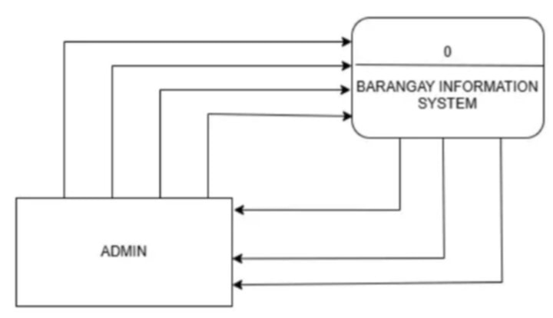

The diagram illustrates that the administrator inputs data into the system, and in return, the system processes and provides relevant information back to the administrator. This interaction highlights a two-way communication flow where the admin acts as the initiator by entering data, and the system responds by generating or retrieving the required information. The process ensures that the admin has the necessary data for decision-making, monitoring, or further actions. Additionally, this exchange can involve various system functions, such as data validation, querying databases, or generating reports, enhancing the efficiency and effectiveness of the administrative tasks.

(Insert here the Level 1 DFD)

**Figure 5. Level 1 Data Flow Diagram**

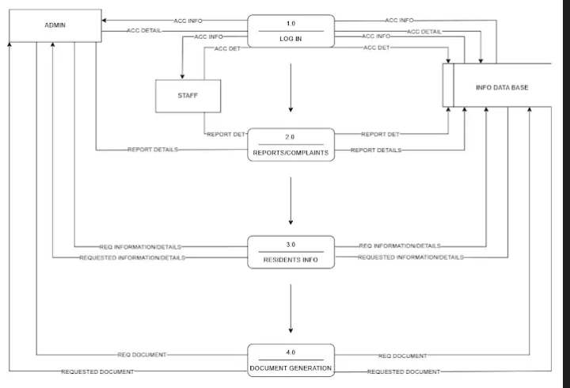

The diagram illustrates the flow of information between the administrator and staff as they input data into the system. Both the admin and staff contribute information, which is then processed and stored within the system. This flow enables seamless data management and ensures that both parties have access to the necessary information. The system acts as a central hub where data from various users is collected, organized, and made available for review, analysis, or further action. The interaction between admin, staff, and the system enhances collaboration, streamlines operations, and improves decision-making by providing real-time access to relevant data. Additionally, the system may include features for tracking inputs, generating reports, and ensuring data integrity, further supporting effective communication and workflow.

**Flow Chart**

(Definition and use of flowchart)

GATHERING INFORMATION

DEVELOP STRATEGY

IMPLEMENT PLAN

EVALUATE RESULTS

ANALYZE DATA

(Insert here the flow chart)

**Figure 6. Flow Chart**

(Explain figure 6)

**Visual Table of Contents**

(Definition and use of VTOC)

(Insert here the VTOC)

**Figure 6. VTOC(Menu)**

